BOC API Document
RR COMPLETED
“Ship”:
- /api/v1.0/SettingsGeneral/view
- /api/v1.0/vendor/getAllActive
- /api/v1.0/customers/getAllActive
- /api/v1.0/RRShipping/shipViaList
- /api/v1.0/address/list

- “/api/v1.0/SettingsGeneral/view”
Open “Front End” codebase”:
Search the API in “restURI.ts” file:
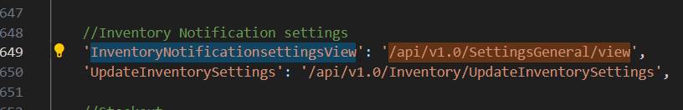
Copy: “InventoryNotificationsettingsView” to search in frontend.
Open “Back End” codebase:
Open “settings.general.routes.js”,
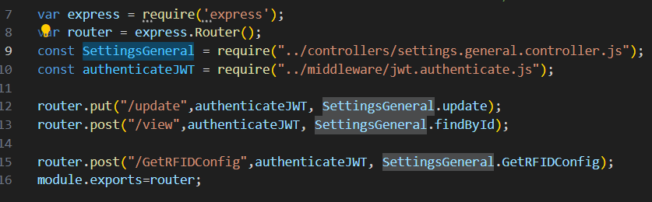
“Right” click on “SettingsGeneral.findById” in line 13, click “Go to Definition”, it shows the code in “settings.general.controller.js”,
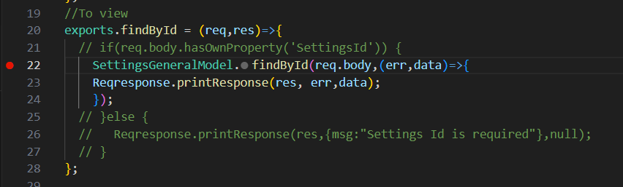
“Right” click on “findById” in line 22, click “Go to Definition”, it shows its “SQL” codebase in “settings.general.model.js” in line 89,
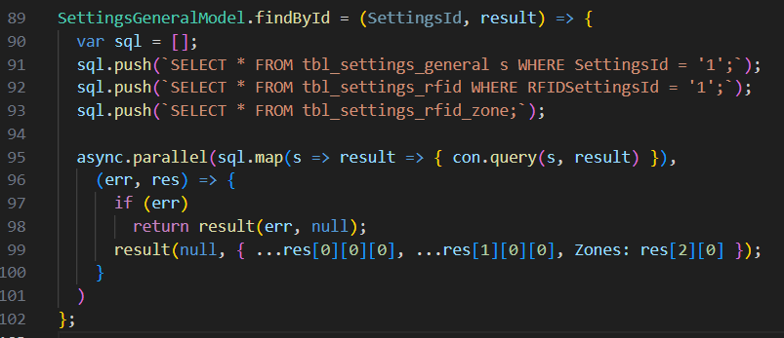

- “/api/v1.0/vendor/getAllActive”: Repeated
- “/api/v1.0/customers/getAllActive”: Repeated
- “/api/v1.0/RRShipping/shipViaList”
Open “Front End” codebase”:
Search the API in “restURI.ts” file:
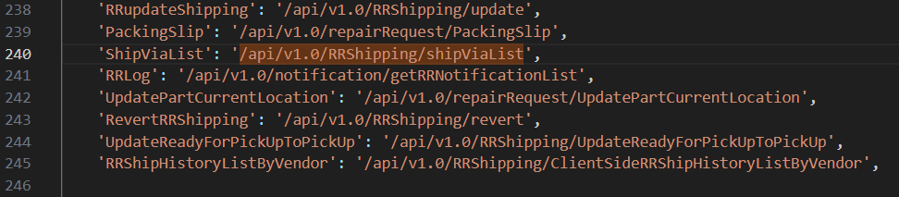

Copy: “ShipViaList” to search in frontend.
Open “Back End” codebase:
Open “repair.request.shipping.history.routes.js”,
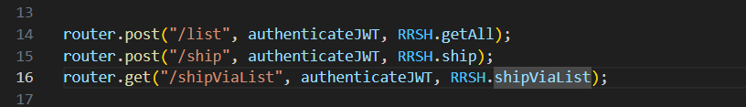
“Right” click on “RRSH.ShipViaList” in line 16, click “Go to Definition”, it shows the code in “repair.request.shipping.history.controller.js”,
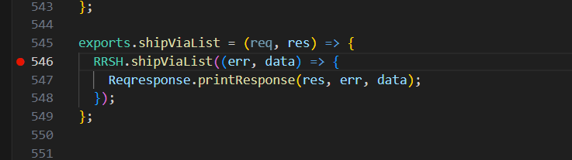
“Right” click on “ShipviaList” in line 546, click “Go to Definition”, it shows its “SQL” codebase in “repair.request.shipping.history.model.js” in line 859,
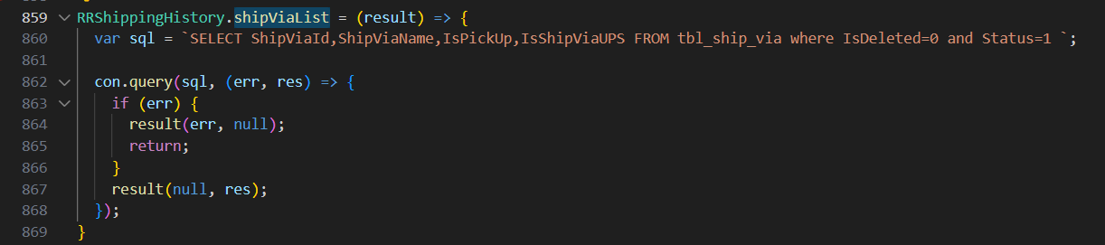

- “/api/v1.0/address/list”: Repeated

“Shipping to: Vendor”:
- /api/v1.0/address/list

- “/api/v1.0/address/list”: Repeated
“Submit”:
- /api/v1.0/RRShipping/ship
- /api/v1.0/notification/getLatest
- /api/v1.0/repairRequest/WorkchainMyTaskCount
- /api/v1.0/ecommerce/product/cartCount
- /api/v1.0/country/list
- /api/v1.0/repairRequest/view
- /users/getAllActiveAdmin
- /api/v1.0/RRSubStatus/dropdown
- /api/v1.0/currencyExchangeRate/exchange
- /api/v1.0/address/list

- “/api/v1.0/RRShipping/ship”

Open “Front End” codebase”:
Search the API in “restURI.ts” file:
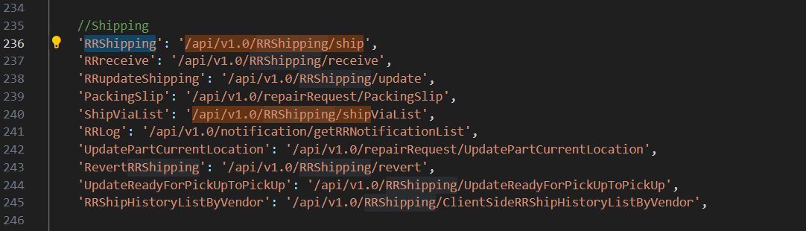

Copy: “RRshipping” to search in frontend.
Open “Back End” codebase:
Open “repair.request.shipping.history.routes.js”,
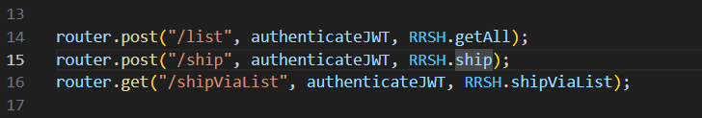
“Right” click on “RRSH.ship” in line 15, click “Go to Definition”, it shows the code in “repair.request.shipping.history.controller.js”,
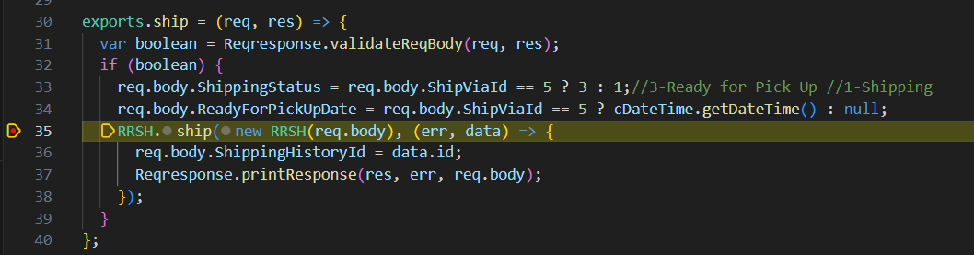
“Right” click on “ship” in line 35, click “Go to Definition”, it shows its “SQL” codebase in “repair.request.shipping.history.model.js” in line 73,
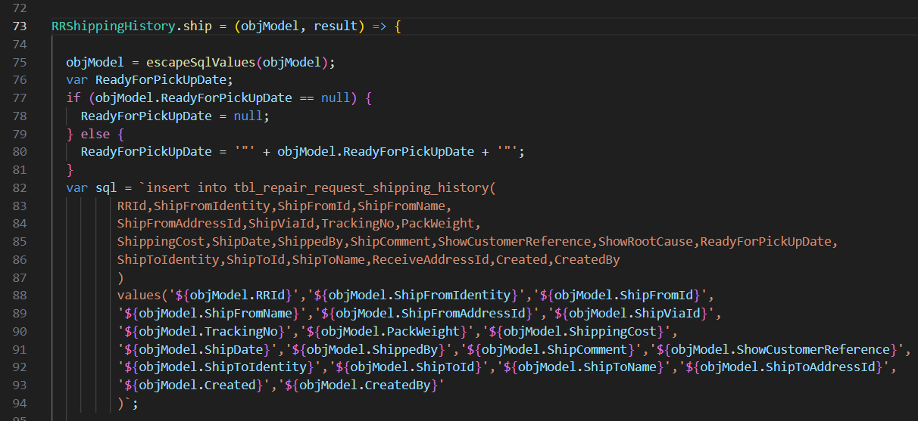

- “/api/v1.0/notification/getLatest”: Repeated
- “/api/v1.0/repairRequest/WorkchainMyTaskCount”: Repeated
- “/api/v1.0/ecommerce/product/cartCount”: Repeated
- “/api/v1.0/country/list”: Repeated
- “/api/v1.0/repairRequest/view”: Repeated
- “/users/getAllActiveAdmin”: Repeated
- “/api/v1.0/RRSubStatus/dropdown”: Repeated
- “/api/v1.0/currencyExchangeRate/exchange”: Repeated
- “/api/v1.0/address/list”: Repeated

“Receive”:
- /api/v1.0/address/list

- “/api/v1.0/address/list”: Repeated

“Receive button”:
- /api/v1.0/RRShipping/receive
- /api/v1.0/notification/getLatest
- /api/v1.0/repairRequest/WorkchainMyTaskCount
- /api/v1.0/ecommerce/product/cartCount
- /api/v1.0/country/list
- /api/v1.0/repairRequest/view
- /users/getAllActiveAdmin
- /api/v1.0/RRSubStatus/dropdown
- /api/v1.0/currencyExchangeRate/exchange
- /api/v1.0/address/list

- “/api/v1.0/RRShipping/receive”
Open “Front End” codebase”:
Search the API in “restURI.ts” file:
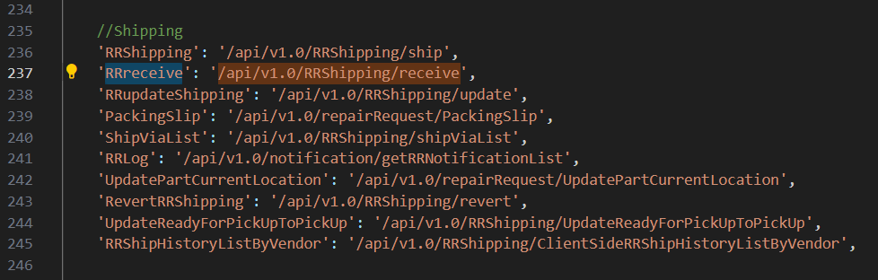
Copy: “RRreceive” to search in frontend.
Open “Back End” codebase:
Open “repair.request.shipping.history.routes.js”,
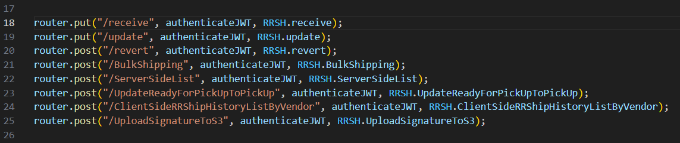
“Right” click on “RRSH.receive” in line 18, click “Go to Definition”, it shows the code in “repair.request.shipping.history.controller.js”,
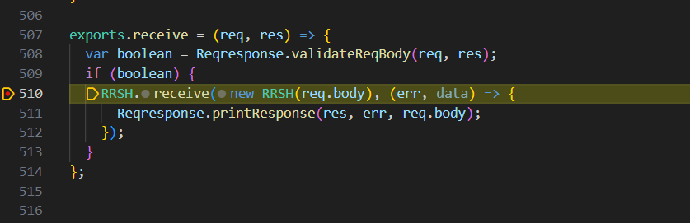
“Right” click on “receive” in line 510, click “Go to Definition”, it shows its “SQL” codebase in “repair.request.shipping.history.model.js” in line 289,
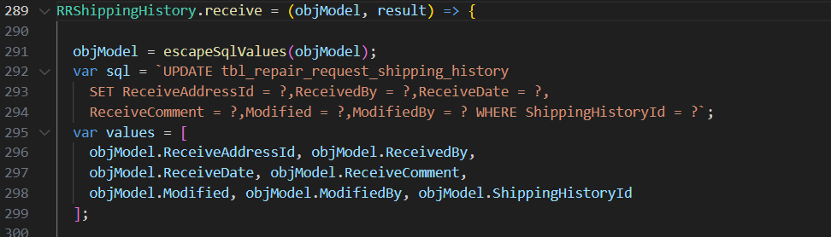
and so on.

- “/api/v1.0/notification/getLatest”: Repeated
- “/api/v1.0/repairRequest/WorkchainMyTaskCount”: Repeated
- “/api/v1.0/ecommerce/product/cartCount”: Repeated
- “/api/v1.0/country/list”: Repeated
- “/api/v1.0/repairRequest/view”: Repeated
- “/users/getAllActiveAdmin”: Repeated
- “/api/v1.0/RRSubStatus/dropdown”: Repeated
- “/api/v1.0/currencyExchangeRate/exchange”: Repeated
- “/api/v1.0/address/list”: Repeated

“Create Customer SO, Yes, create it.”:
- /api/v1.0/SalesOrder/autocreate
- /api/v1.0/notification/getLatest
- /api/v1.0/repairRequest/WorkchainMyTaskCount
- /api/v1.0/ecommerce/product/cartCount
- /api/v1.0/country/list
- /api/v1.0/repairRequest/view
- /users/getAllActiveAdmin
- /api/v1.0/RRSubStatus/dropdown
- /api/v1.0/currencyExchangeRate/exchange
- /api/v1.0/address/list

- “/api/v1.0/SalesOrder/autocreate”
Open “Front End” codebase”:
Search the API in “restURI.ts” file:
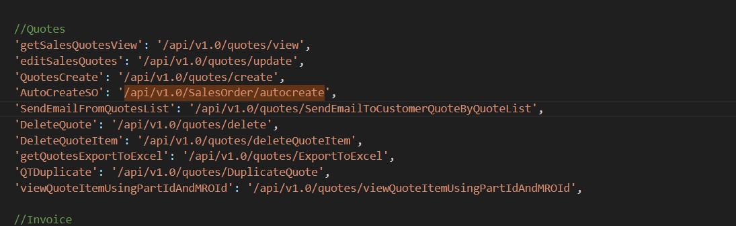
Copy: “AutoCreateSO” to search in frontend.
Open “Back End” codebase:
Open “sales.order.route.js”,
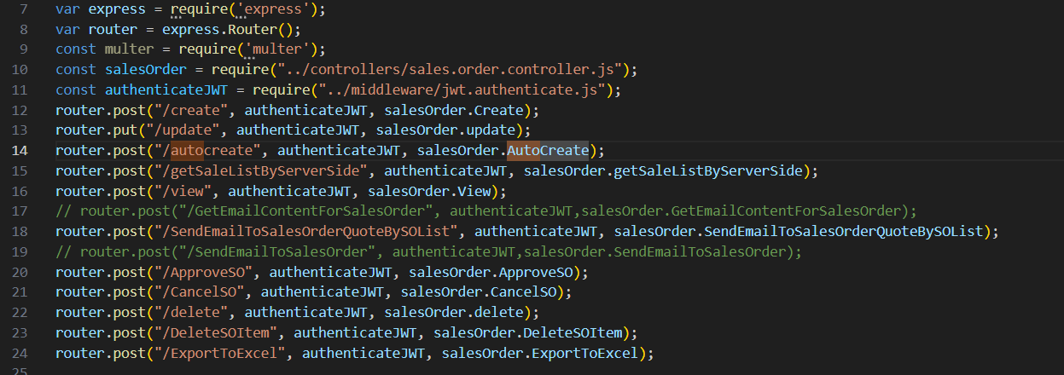
“Right” click on “salesOrder.AutoCreate” in line 14, click “Go to Definition”, it shows the code in “sales.order.controller.js”,
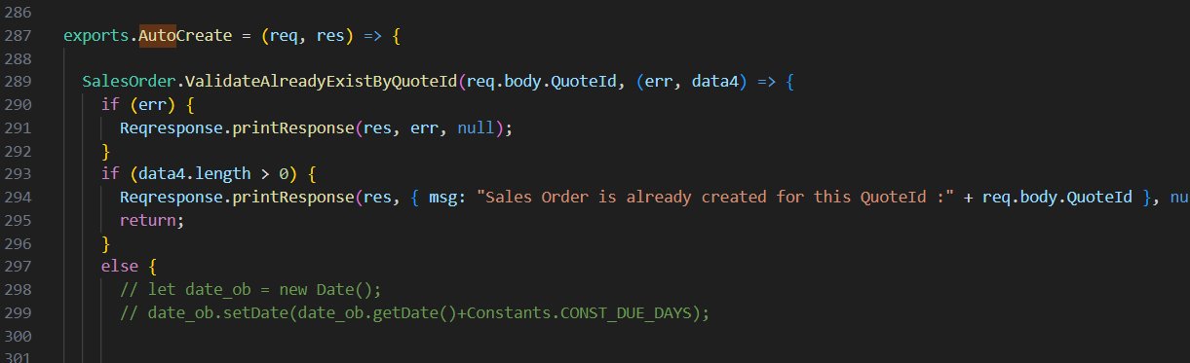
and so on.
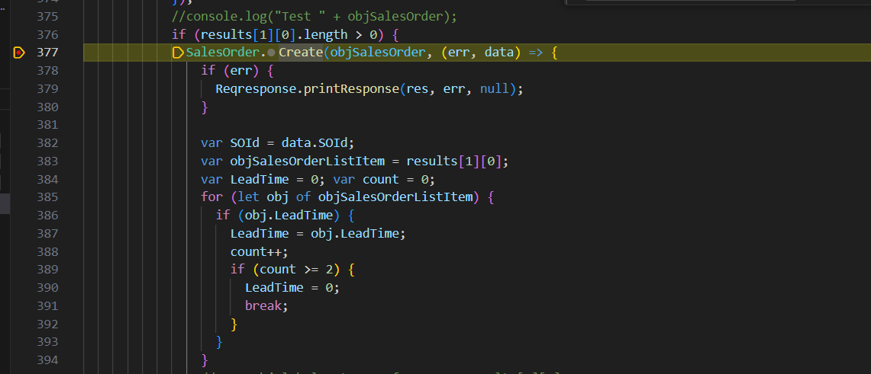
Right” click on “create” in line 377, click “Go to Definition”, it shows its “SQL” codebase in “sales.order.model.js” in line 146,
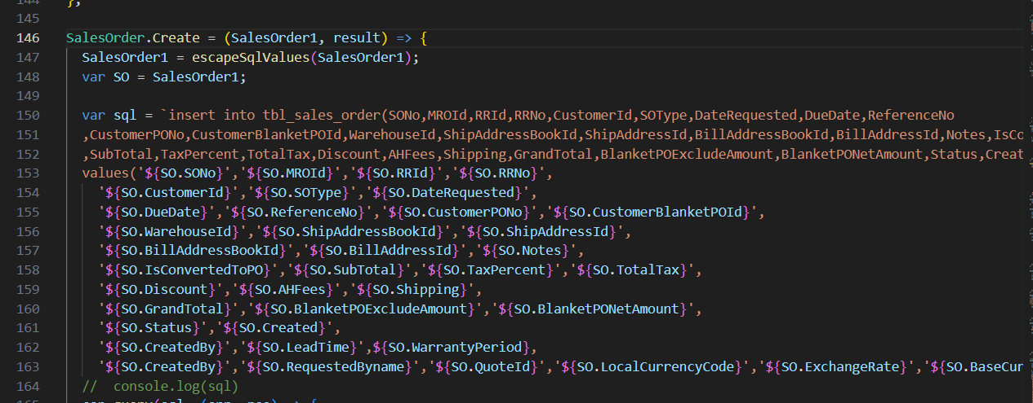

- “/api/v1.0/notification/getLatest”: Repeated
- “/api/v1.0/repairRequest/WorkchainMyTaskCount”: Repeated
- “/api/v1.0/ecommerce/product/cartCount”: Repeated
- “/api/v1.0/country/list”: Repeated
- “/api/v1.0/repairRequest/view”: Repeated
- “/users/getAllActiveAdmin”: Repeated
- “/api/v1.0/RRSubStatus/dropdown”: Repeated
- “/api/v1.0/currencyExchangeRate/exchange”: Repeated
- “/api/v1.0/address/list”: Repeated

“Create Vendor PO, Yes, create it.”:
- /api/v1.0/PurchaseOrder/autocreate
- /api/v1.0/notification/getLatest
- /api/v1.0/repairRequest/WorkchainMyTaskCount
- /api/v1.0/ecommerce/product/cartCount
- /api/v1.0/country/list
- /api/v1.0/repairRequest/view
- /users/getAllActiveAdmin
- /api/v1.0/RRSubStatus/dropdown
- /api/v1.0/currencyExchangeRate/exchange
- /api/v1.0/address/list
- /api/v1.0/address/list

- “/api/v1.0/PurchaseOrder/autocreate”:
Open “Front End” codebase”:
Search the API in “restURI.ts” file:
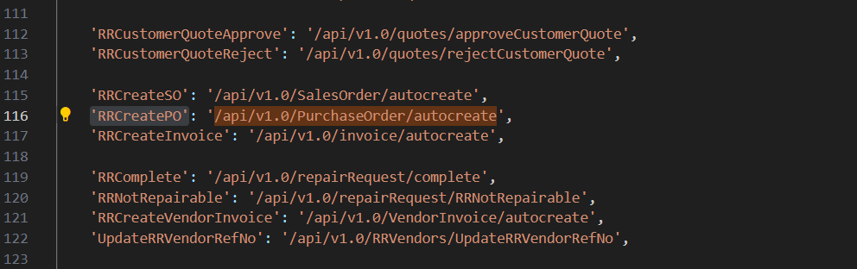
Copy: “RRCreatePO” to search in frontend.
Open “Back End” codebase:
Open “purchase.order.route.js”,
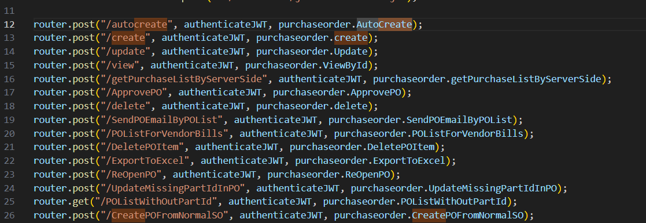
“Right” click on “purchaseorder.AutoCreate” in line 12, click “Go to Definition”, it shows the code in “purchase.order.controller.js”,
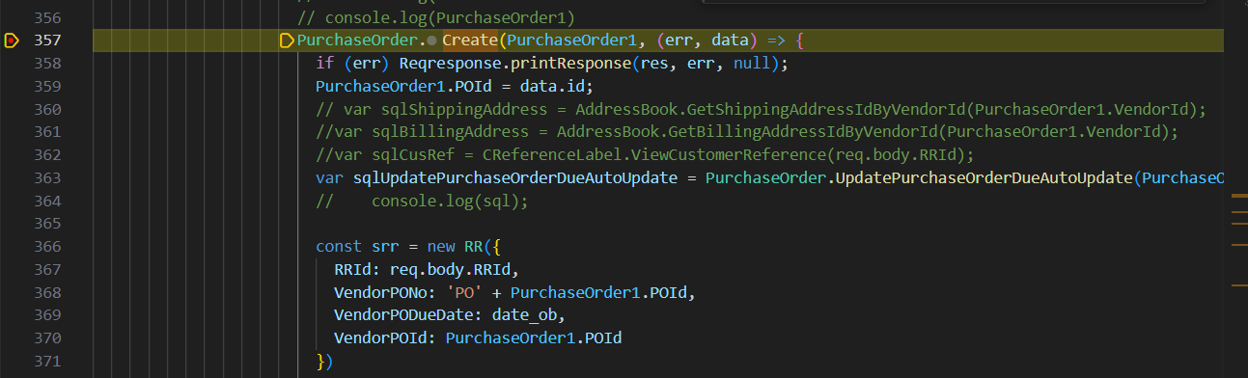
Right” click on “Create” in line 357, click “Go to Definition”, it shows its “SQL” codebase in “purchase.order.model.js” in line 617,
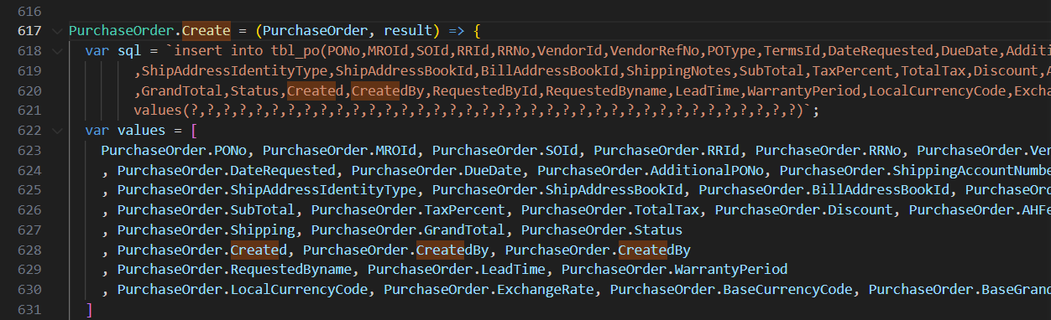
and so on.

- “/api/v1.0/notification/getLatest”: Repeated
- “/api/v1.0/repairRequest/WorkchainMyTaskCount”: Repeated
- “/api/v1.0/ecommerce/product/cartCount”: Repeated
- “/api/v1.0/country/list”: Repeated
- “/api/v1.0/repairRequest/view”: Repeated
- “/users/getAllActiveAdmin”: Repeated
- “/api/v1.0/RRSubStatus/dropdown”: Repeated
- “/api/v1.0/currencyExchangeRate/exchange”: Repeated
- “/api/v1.0/address/list”: Repeated
- “/api/v1.0/address/list”: Repeated

“Ship”:
- /api/v1.0/SettingsGeneral/view
- /api/v1.0/vendor/getAllActive
- /api/v1.0/customers/getAllActive
- /api/v1.0/RRShipping/shipViaList
- /api/v1.0/address/list

- “/api/v1.0/SettingsGeneral/view”: Repeated
- “/api/v1.0/vendor/getAllActive”: Repeated
- “/api/v1.0/customers/getAllActive”: Repeated
- “/api/v1.0/RRShipping/shipViaList”: Repeated
- “/api/v1.0/address/list”: Repeated

“Shipping to :Aibond”:
- /api/v1.0/address/GetAHGroupVendorAddress

- “/api/v1.0/address/GetAHGroupVendorAddress”: Repeated

“Submit”:
- /api/v1.0/RRShipping/ship
- /api/v1.0/notification/getLatest
- /api/v1.0/repairRequest/WorkchainMyTaskCount
- /api/v1.0/ecommerce/product/cartCount
- /api/v1.0/country/list
- /api/v1.0/repairRequest/view
- /users/getAllActiveAdmin
- /api/v1.0/RRSubStatus/dropdown
- /api/v1.0/currencyExchangeRate/exchange
- /api/v1.0/address/list

- “/api/v1.0/RRShipping/ship”: Repeated
- “/api/v1.0/notification/getLatest”: Repeated
- “/api/v1.0/repairRequest/WorkchainMyTaskCount”: Repeated
- “/api/v1.0/ecommerce/product/cartCount”: Repeated
- “/api/v1.0/country/list”: Repeated
- “/api/v1.0/repairRequest/view”: Repeated
- “/users/getAllActiveAdmin”: Repeated
- “/api/v1.0/RRSubStatus/dropdown”: Repeated
- “/api/v1.0/currencyExchangeRate/exchange”: Repeated
- “/api/v1.0/address/list”: Repeated

“Receive”:
- /api/v1.0/address/GetAHGroupVendorAddress

- “/api/v1.0/address/GetAHGroupVendorAddress”: Repeated

“Receive button”:
- /api/v1.0/RRShipping/receive
- /api/v1.0/notification/getLatest
- /api/v1.0/repairRequest/WorkchainMyTaskCount
- /api/v1.0/ecommerce/product/cartCount
- /api/v1.0/country/list
- /api/v1.0/repairRequest/view
- /users/getAllActiveAdmin
- /api/v1.0/RRSubStatus/dropdown
- /api/v1.0/currencyExchangeRate/exchange
- /api/v1.0/address/list
- /api/v1.0/address/GetAHGroupVendorAddress

- “/api/v1.0/RRShipping/receive”: Repeated
- “/api/v1.0/notification/getLatest”: Repeated
- “/api/v1.0/repairRequest/WorkchainMyTaskCount”: Repeated
- “/api/v1.0/ecommerce/product/cartCount”: Repeated
- “/api/v1.0/country/list”: Repeated
- “/api/v1.0/repairRequest/view”: Repeated
- “/users/getAllActiveAdmin”: Repeated
- “/api/v1.0/RRSubStatus/dropdown”: Repeated
- “/api/v1.0/currencyExchangeRate/exchange”: Repeated
- “/api/v1.0/address/list”: Repeated
- “/api/v1.0/address/GetAHGroupVendorAddress”: Repeated

“Create Vendor Bill: Submit”:
- /api/v1.0/VendorInvoice/autocreate
- /api/v1.0/notification/getLatest
- /api/v1.0/repairRequest/WorkchainMyTaskCount
- /api/v1.0/ecommerce/product/cartCount
- /api/v1.0/country/list
- /api/v1.0/repairRequest/view
- /users/getAllActiveAdmin
- /api/v1.0/RRSubStatus/dropdown
- /api/v1.0/currencyExchangeRate/exchange
- /api/v1.0/address/list
- /api/v1.0/address/GetAHGroupVendorAddress

- “/api/v1.0/VendorInvoice/autocreate”:
Open “Front End” codebase”:
Search the API in “restURI.ts” file:
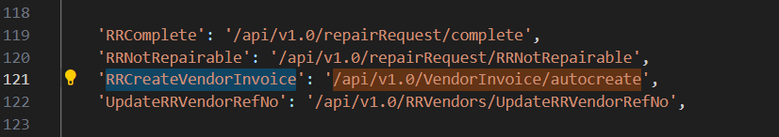
Copy: “RRCreateVendorInvoice” to search in frontend.
Open “Back End” codebase:
Open “vendor.invoice.route.js”,
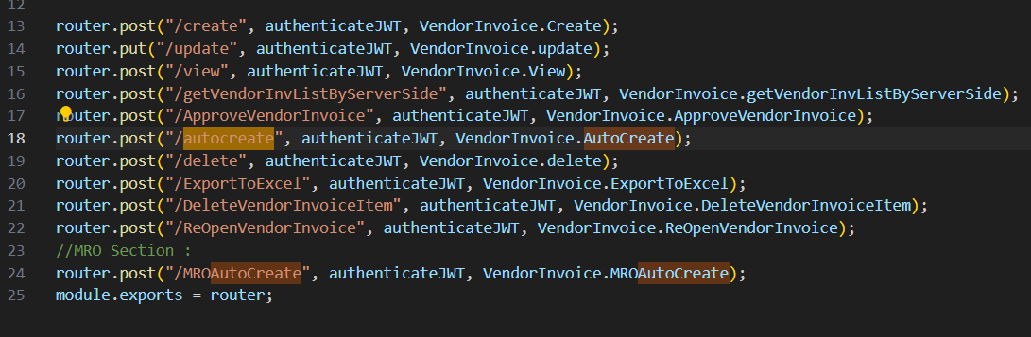
“Right” click on “VendorInvoiceAutoCreate” in line 18, click “Go to Definition”, it shows the code in “vendor.invoice.controller.js”,
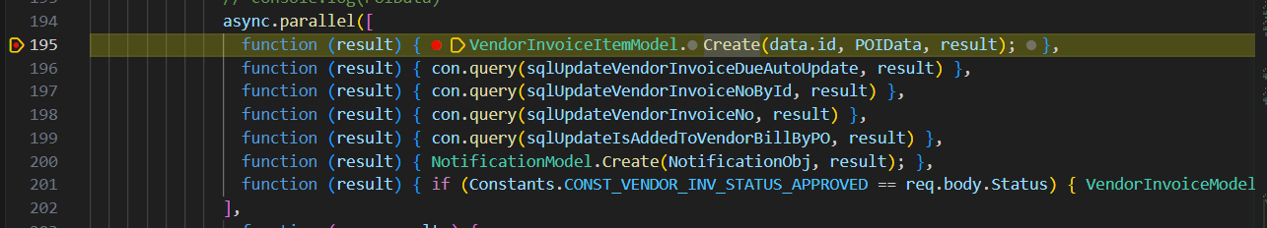
Right” click on “Create” in line 195, click “Go to Definition”, it shows its “SQL” codebase in “vendor.invoice.model.js” in line 51, 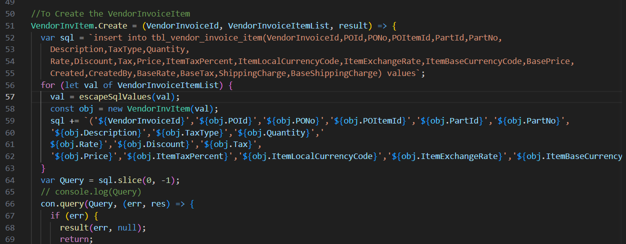and so on.

- “/api/v1.0/notification/getLatest”: Repeated
- “/api/v1.0/repairRequest/WorkchainMyTaskCount”: Repeated
- “/api/v1.0/ecommerce/product/cartCount”: Repeated
- “/api/v1.0/country/list”: Repeated
- “/api/v1.0/repairRequest/view”: Repeated
- “/users/getAllActiveAdmin”: Repeated
- “/api/v1.0/RRSubStatus/dropdown”: Repeated
- “/api/v1.0/currencyExchangeRate/exchange”: Repeated
- “/api/v1.0/address/list”: Repeated
- “/api/v1.0/address/GetAHGroupVendorAddress”: Repeated

“Ship”:
- /api/v1.0/SettingsGeneral/view
- /api/v1.0/vendor/getAllActive
- /api/v1.0/customers/getAllActive
- /api/v1.0/RRShipping/shipViaList
- /api/v1.0/address/list

- “/api/v1.0/SettingsGeneral/view”: Repeated
- “/api/v1.0/vendor/getAllActive”: Repeated
- “/api/v1.0/customers/getAllActive”: Repeated
- “/api/v1.0/RRShipping/shipViaList”: Repeated
- “/api/v1.0/address/list”: Repeated

“Shipping to: Customer”:
- /api/v1.0/address/list

- “/api/v1.0/address/list”: Repeated

“Submit”:
- /api/v1.0/RRShipping/ship
- /api/v1.0/invoice/autocreate
- /api/v1.0/repairRequest/complete
- /api/v1.0/notification/getLatest
- /api/v1.0/repairRequest/WorkchainMyTaskCount
- /api/v1.0/ecommerce/product/cartCount
- /api/v1.0/country/list
- /api/v1.0/repairRequest/view
- /users/getAllActiveAdmin
- /api/v1.0/RRSubStatus/dropdown
- /api/v1.0/currencyExchangeRate/exchange
- /api/v1.0/address/list

- “/api/v1.0/RRShipping/ship”: Repeated
- “/api/v1.0/invoice/autocreate”
Open “Front End” codebase”:
Search the API in “restURI.ts” file:
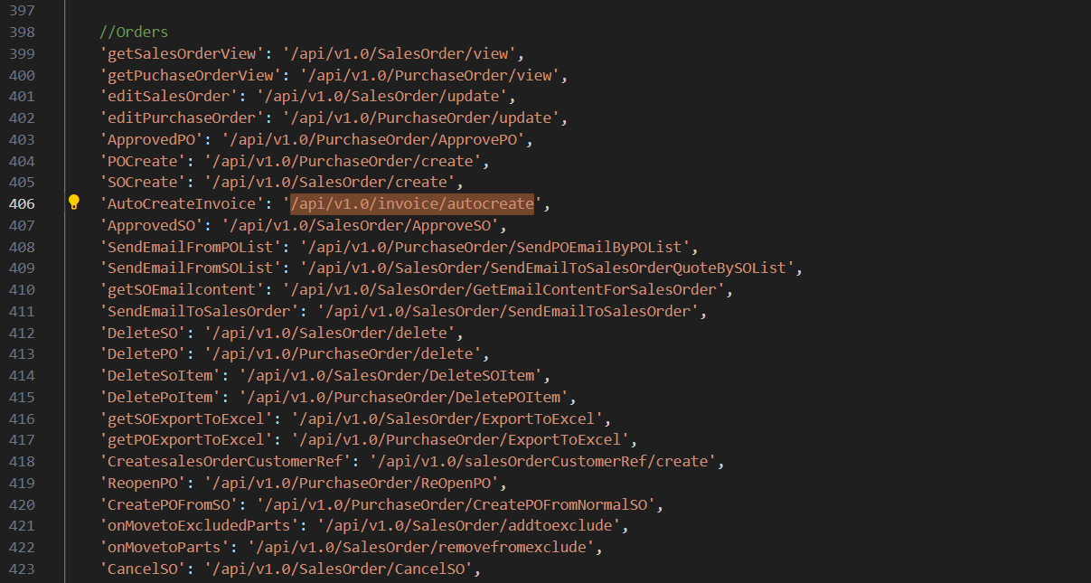
Copy: “AutoCreateInvoice” to search in frontend.
Open “Back End” codebase:
Open “invoice.route.js”,
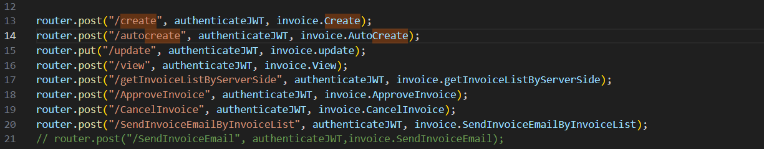
“Right” click on “invoice.AutoCreate” in line 14, click “Go to Definition”, it shows the code in “invoice.controller.js”,
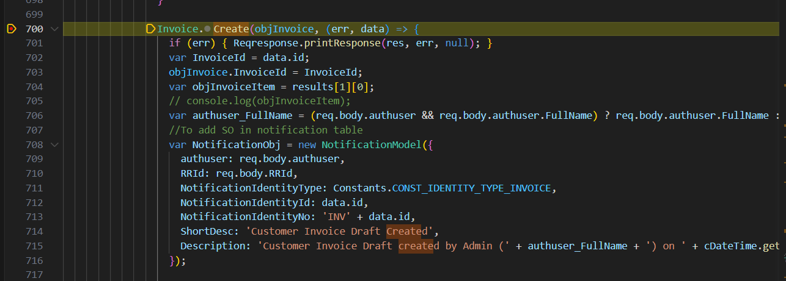
Right” click on “Create” in line 700, click “Go to Definition”, it shows its “SQL” codebase in “invoice.model.js” in line 1118,
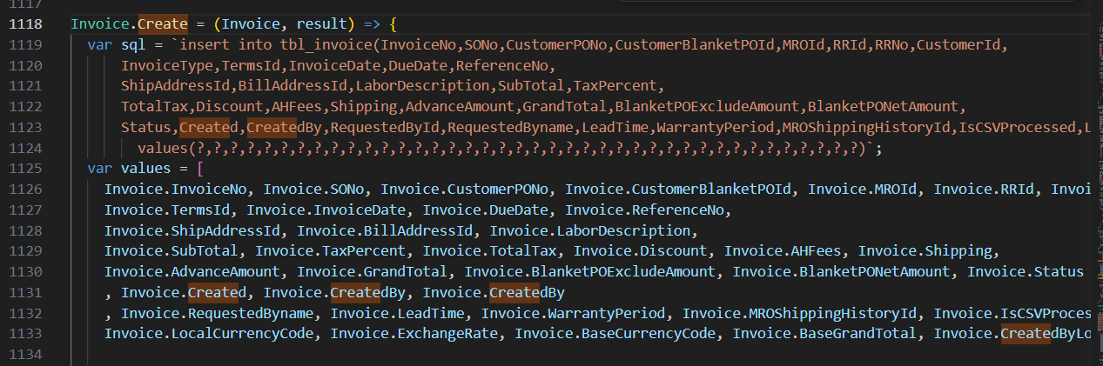
and so on.

- “/api/v1.0/repairRequest/complete”
Open “Front End” codebase”:
Search the API in “restURI.ts” file:
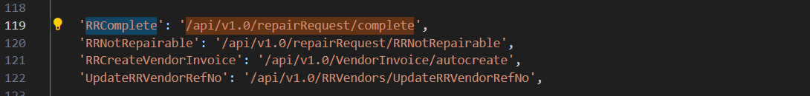
Copy: “RRComplete” to search in frontend.
Open “Back End” codebase:
Open “repairrequest.route.js”,
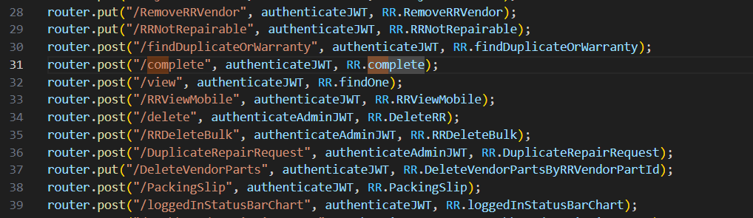
“Right” click on “complete” in line 31, click “Go to Definition”, it shows the code in “repairrequest.controller.js”,

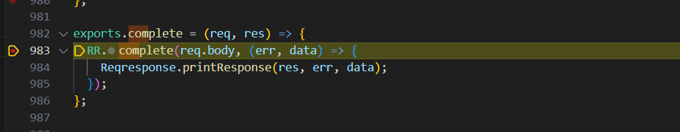
Right” click on “Create” in line 983, click “Go to Definition”, it shows its “SQL” codebase in “repairrequest.model.js” in line 1136,
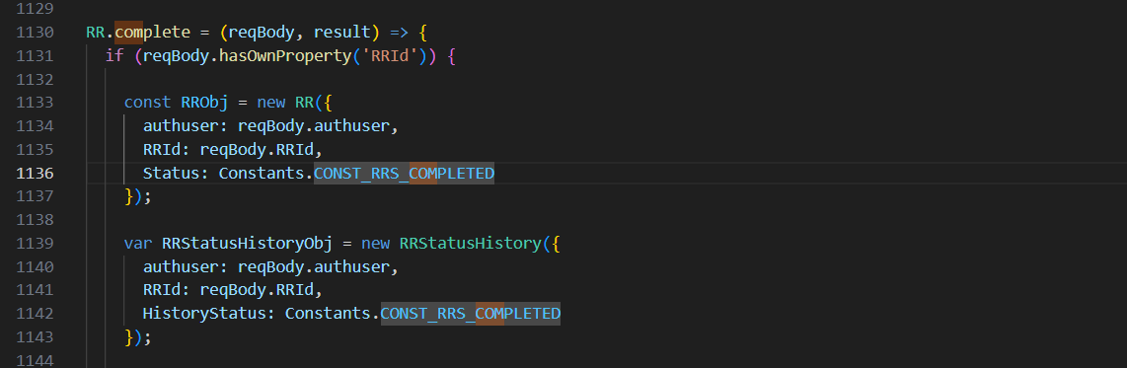
and so on.

- “/api/v1.0/notification/getLatest”: Repeated
- “/api/v1.0/repairRequest/WorkchainMyTaskCount”: Repeated
- “/api/v1.0/ecommerce/product/cartCount”: Repeated
- “/api/v1.0/country/list”: Repeated
- “/api/v1.0/repairRequest/view”: Repeated
- “/users/getAllActiveAdmin”: Repeated
- “/api/v1.0/RRSubStatus/dropdown”: Repeated
- “/api/v1.0/currencyExchangeRate/exchange”: Repeated
- “/api/v1.0/address/list”: Repeated

“Receive by customer”:
- /api/v1.0/address/list

- “/api/v1.0/address/list”: Repeated

“Receive button”:
- /api/v1.0/RRShipping/receive
- /api/v1.0/notification/getLatest
- /api/v1.0/repairRequest/WorkchainMyTaskCount
- /api/v1.0/ecommerce/product/cartCount
- /api/v1.0/country/list
- /api/v1.0/repairRequest/view
- /users/getAllActiveAdmin
- /api/v1.0/RRSubStatus/dropdown
- /api/v1.0/currencyExchangeRate/exchange
- /api/v1.0/address/list

- /api/v1.0/RRShipping/receive”: Repeated
- /api/v1.0/notification/getLatest”: Repeated
- /api/v1.0/repairRequest/WorkchainMyTaskCount”: Repeated
- /api/v1.0/ecommerce/product/cartCount”: Repeated
- /api/v1.0/country/list”: Repeated
- /api/v1.0/repairRequest/view”: Repeated
- /users/getAllActiveAdmin”: Repeated
- /api/v1.0/RRSubStatus/dropdown”: Repeated
- /api/v1.0/currencyExchangeRate/exchange”: Repeated
- /api/v1.0/address/list”: Repeated

